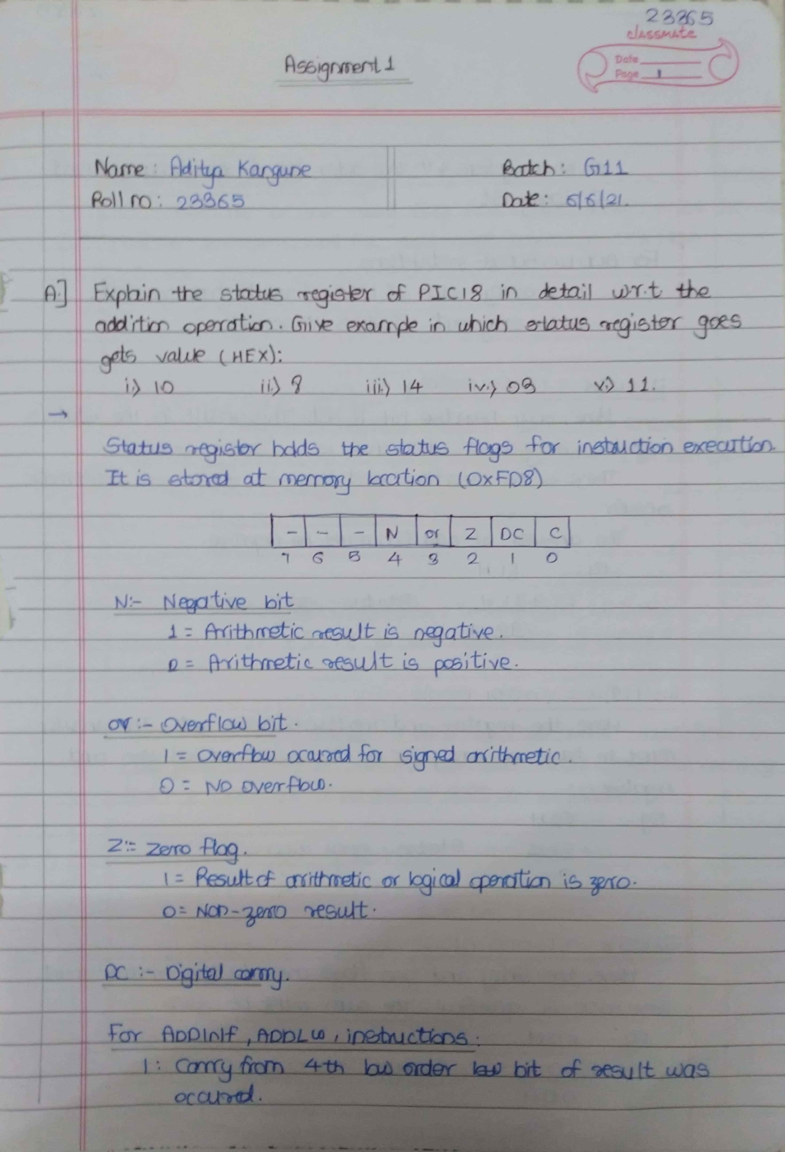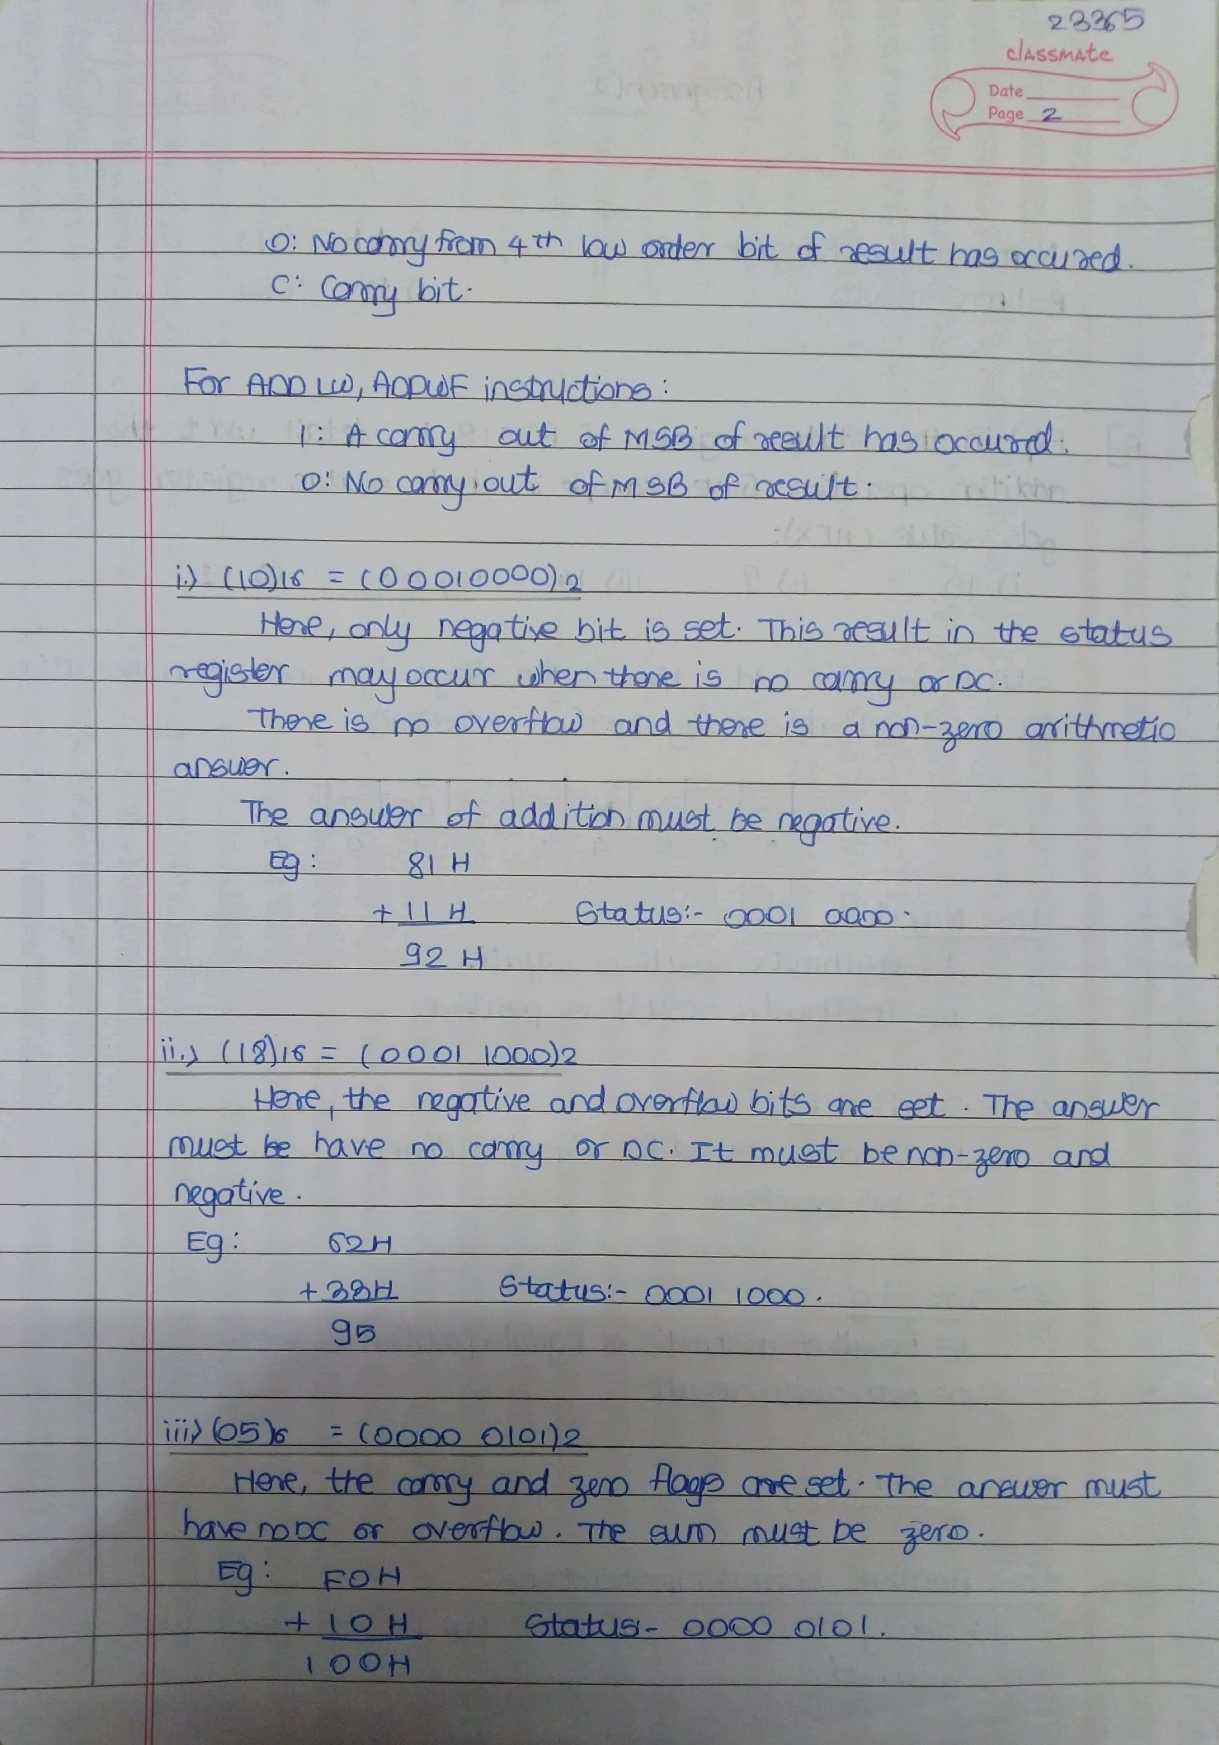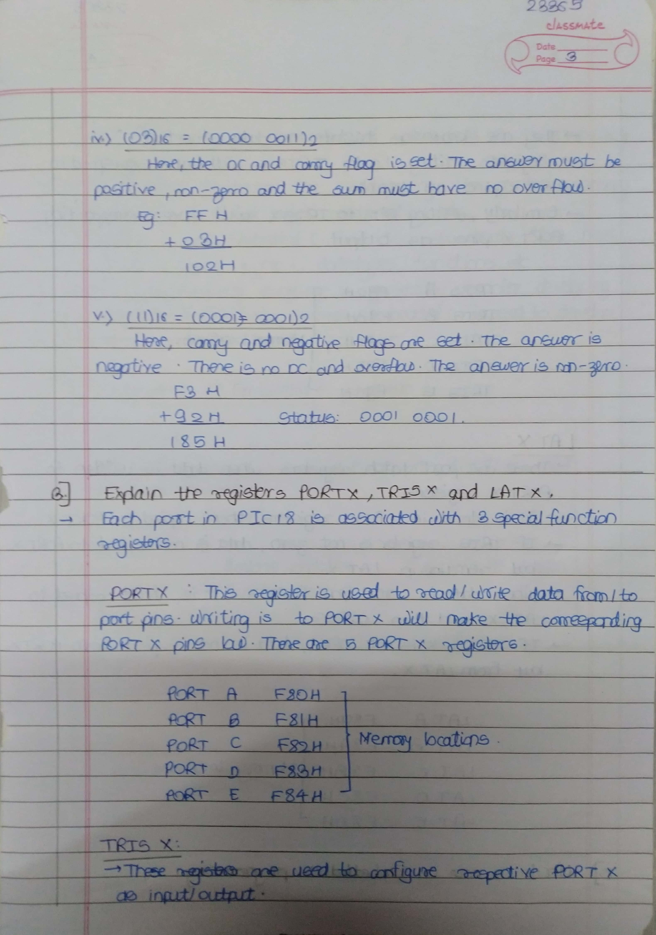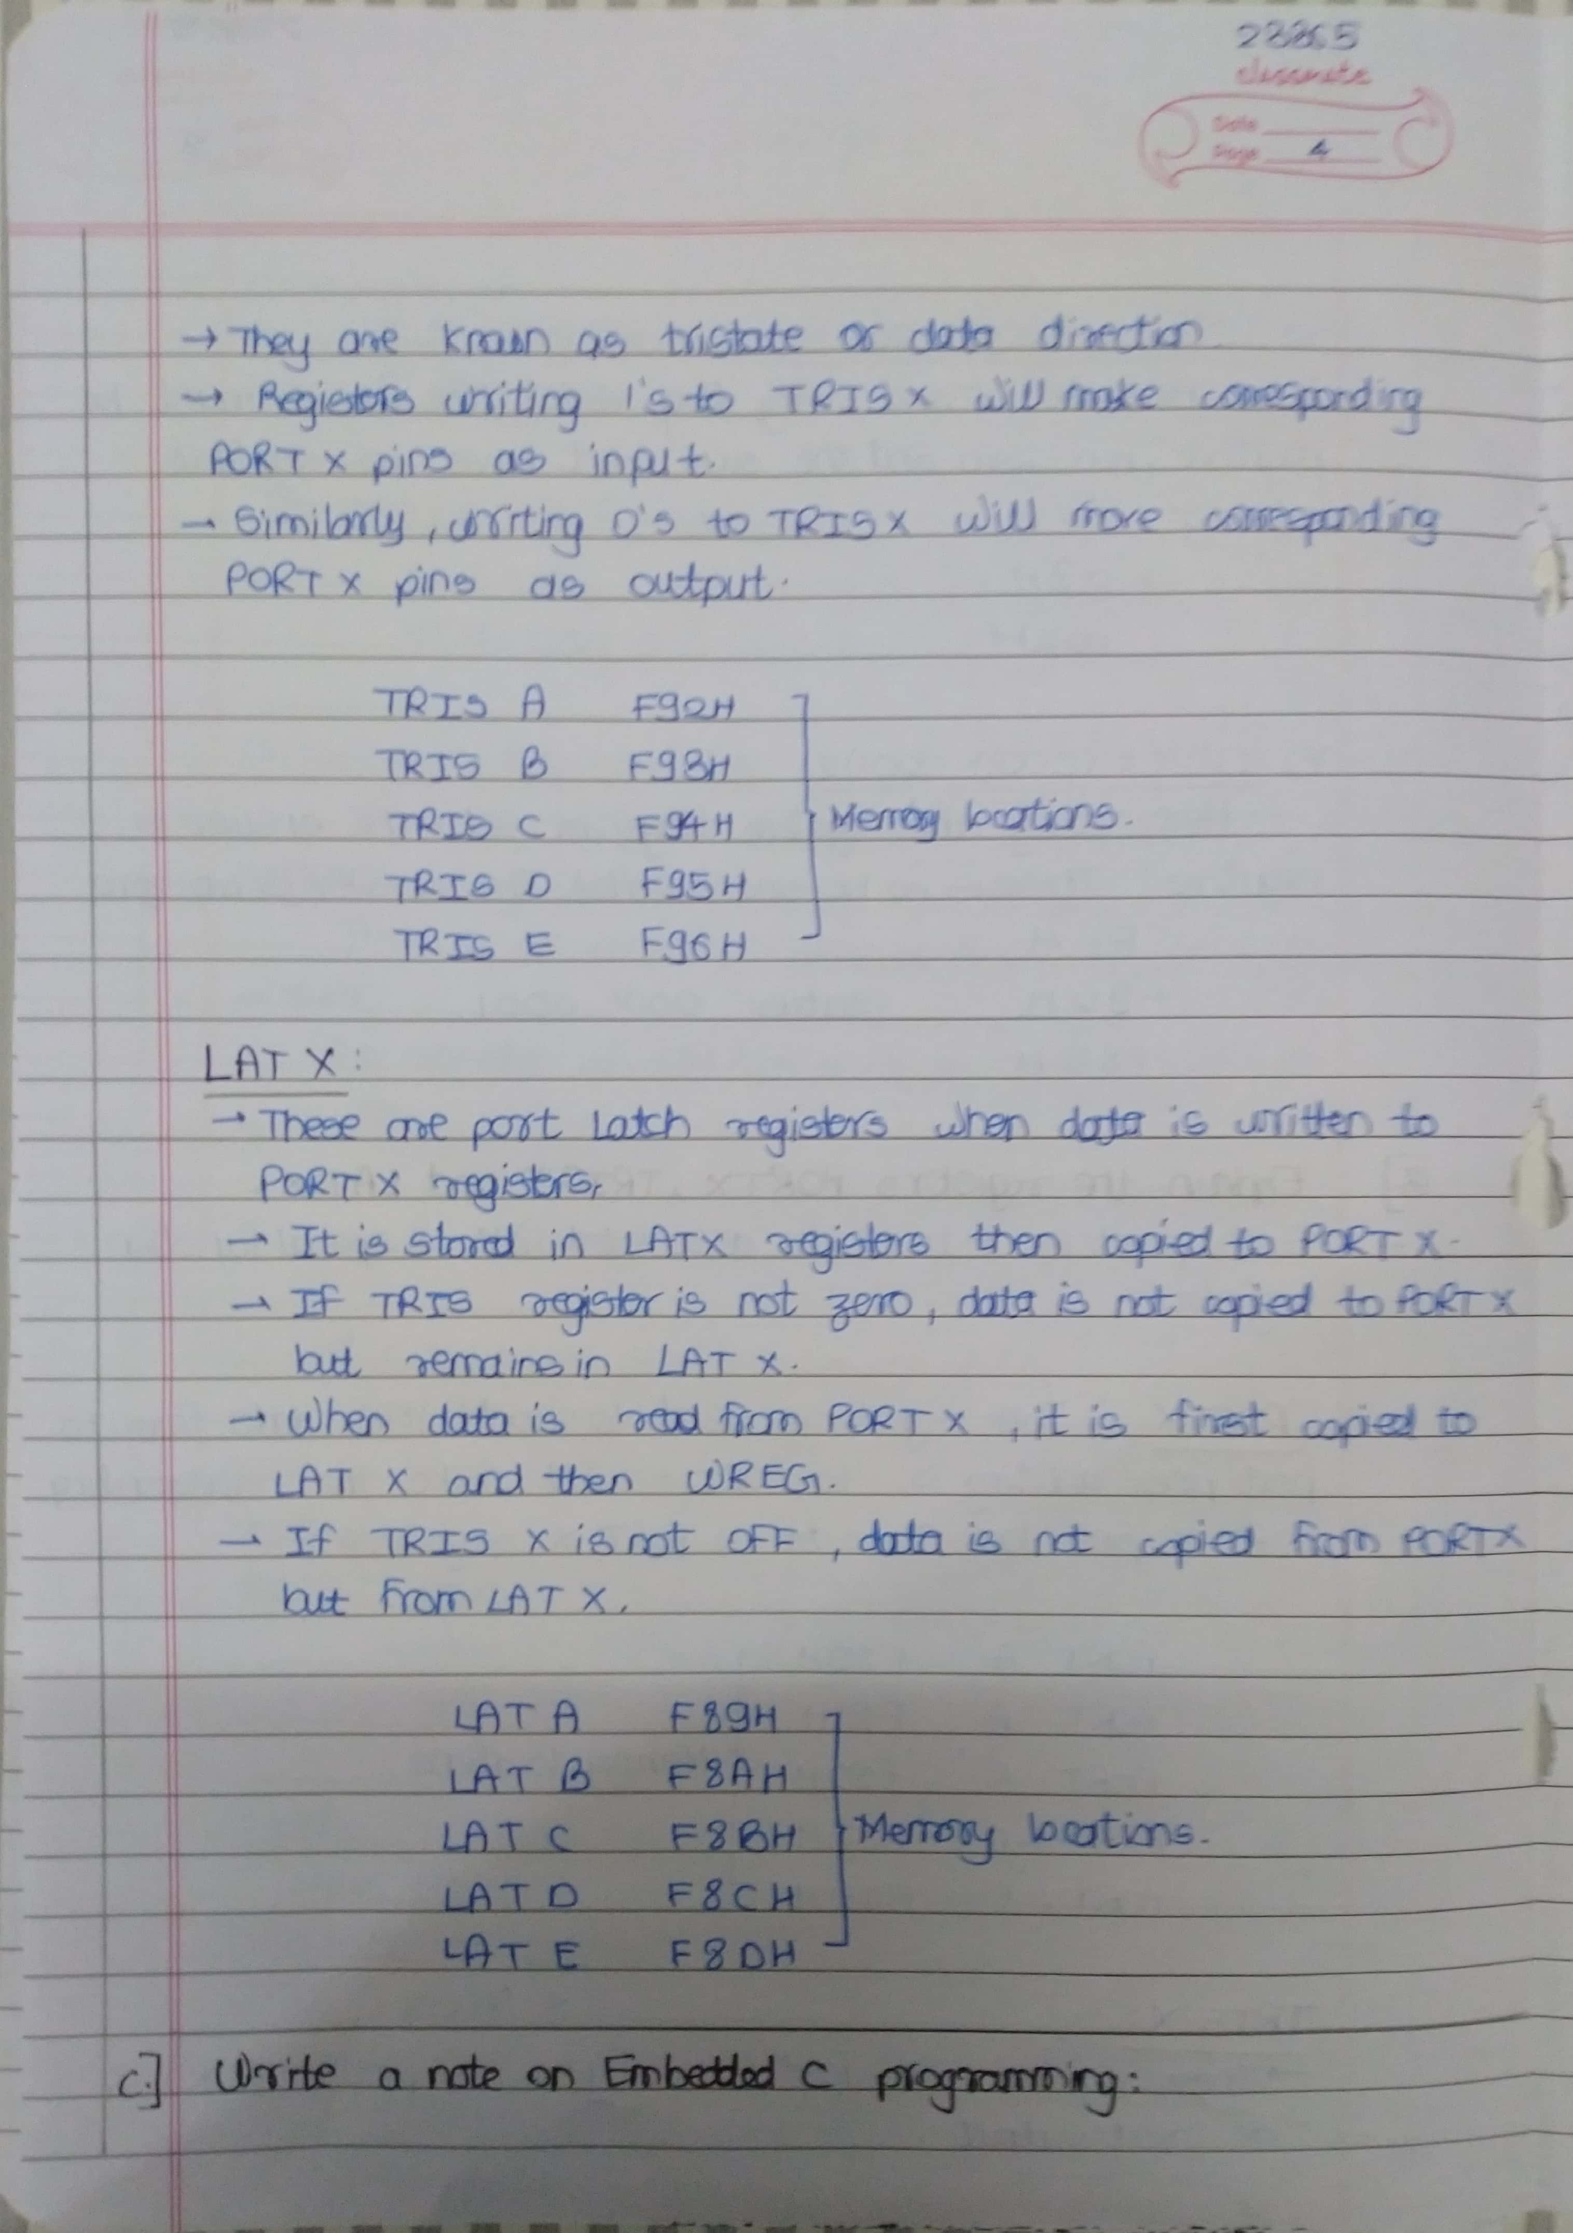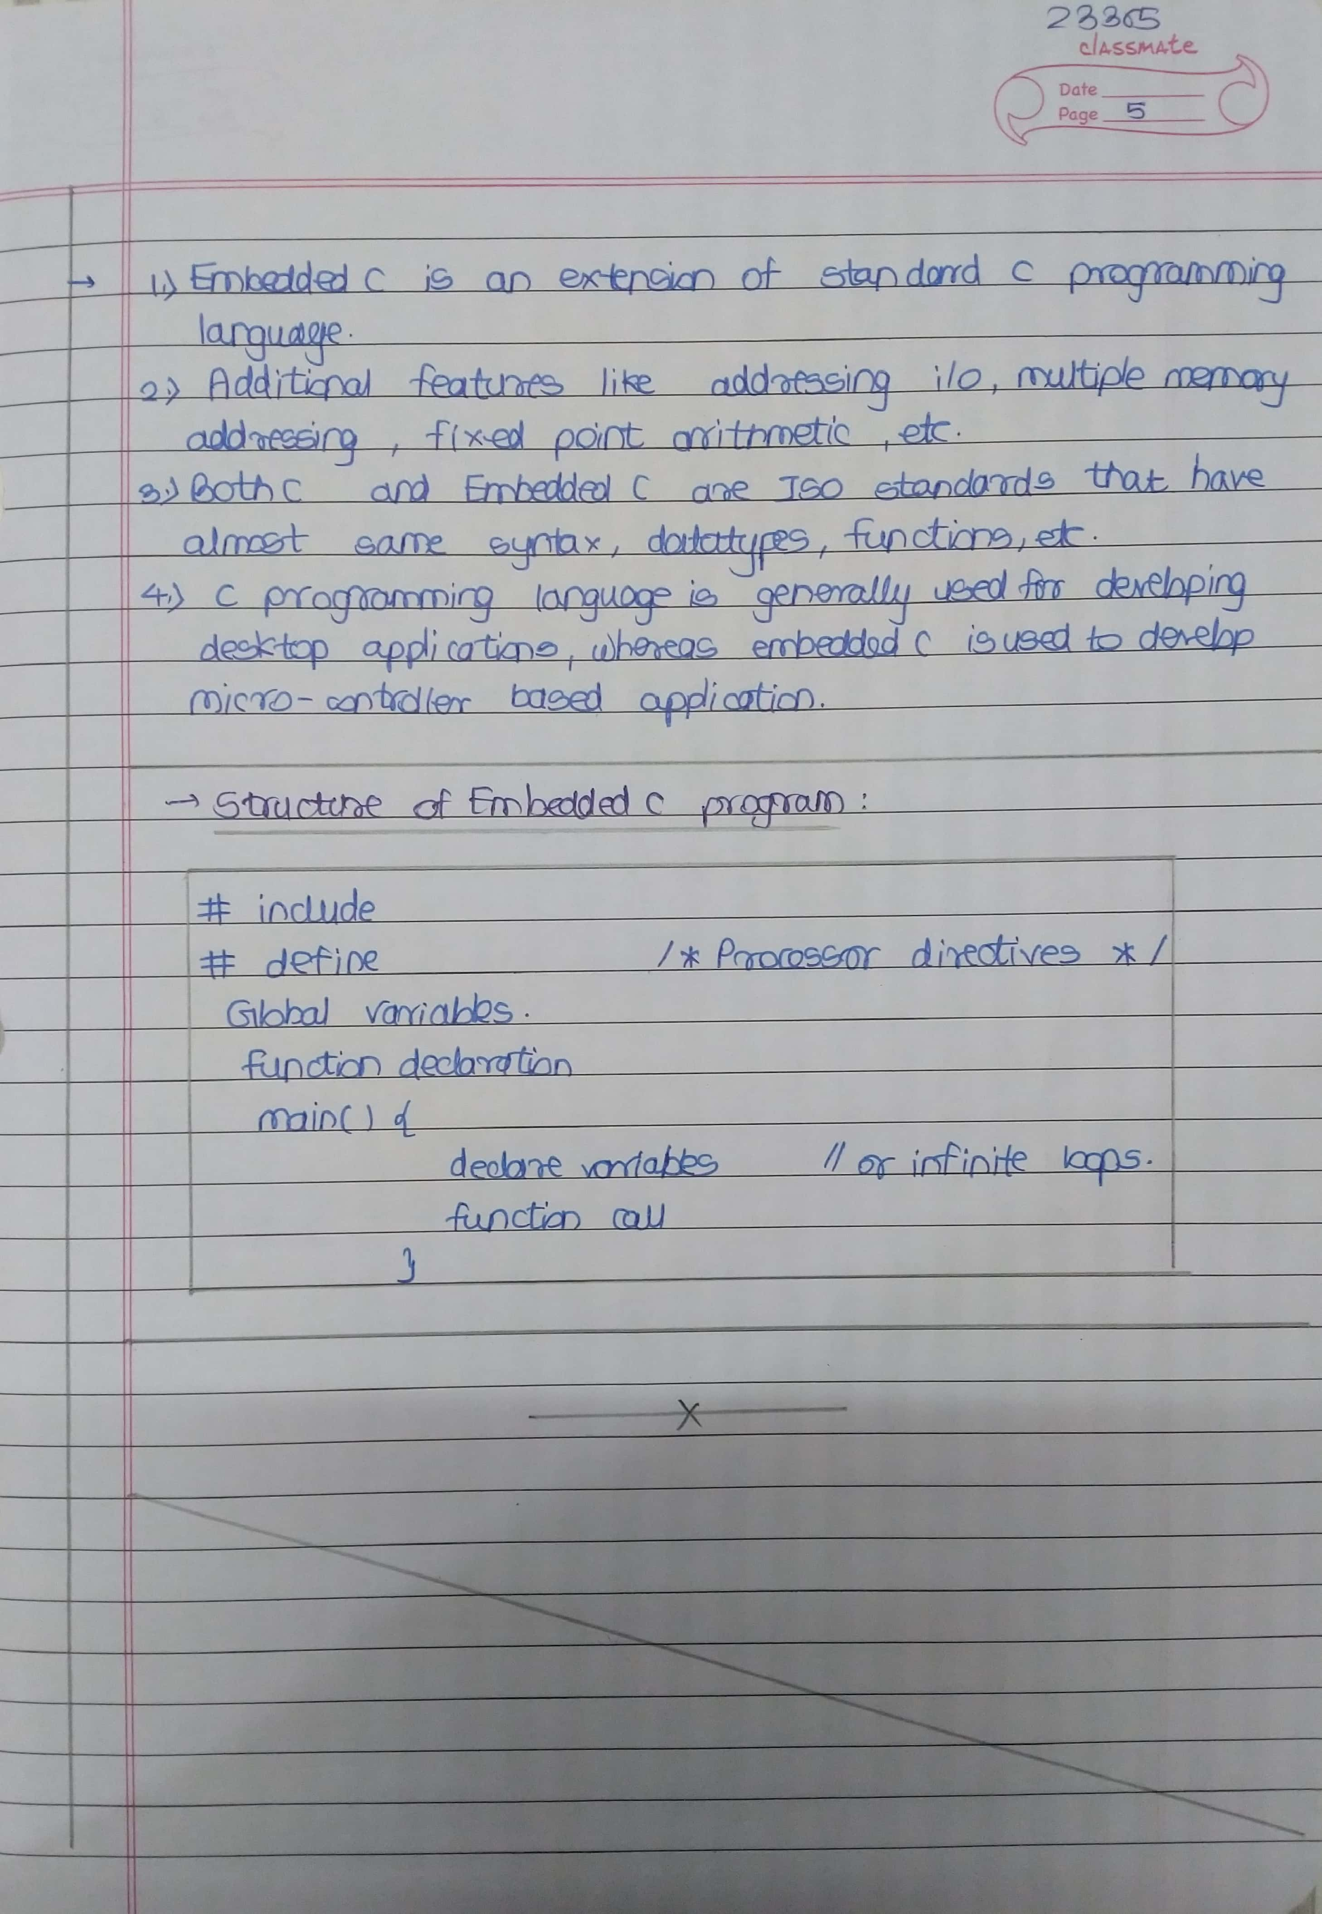

# **Assignment 1 Input-**

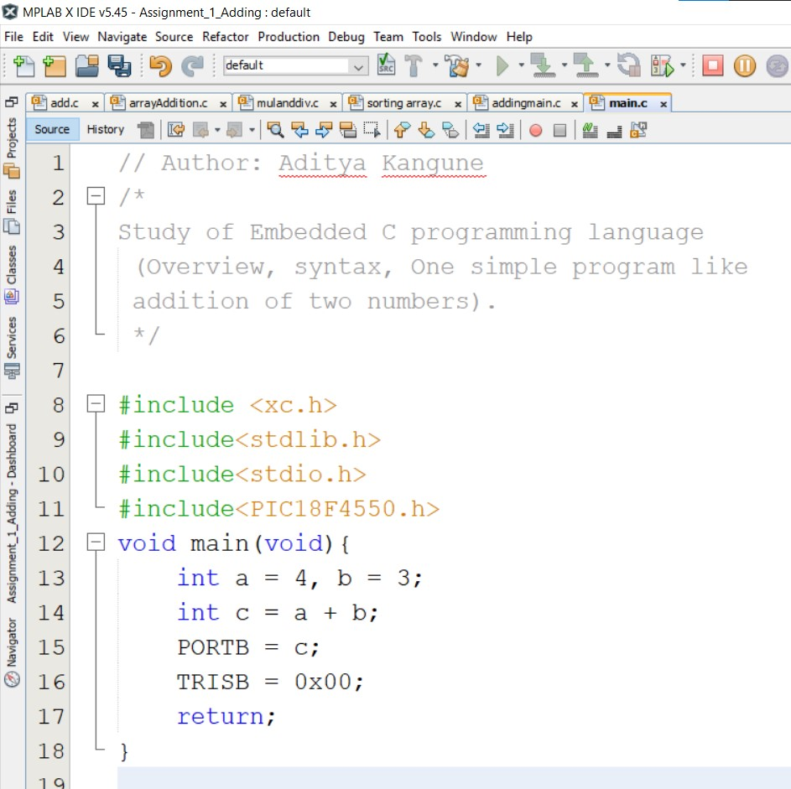

# **Assignment 1 Output-**

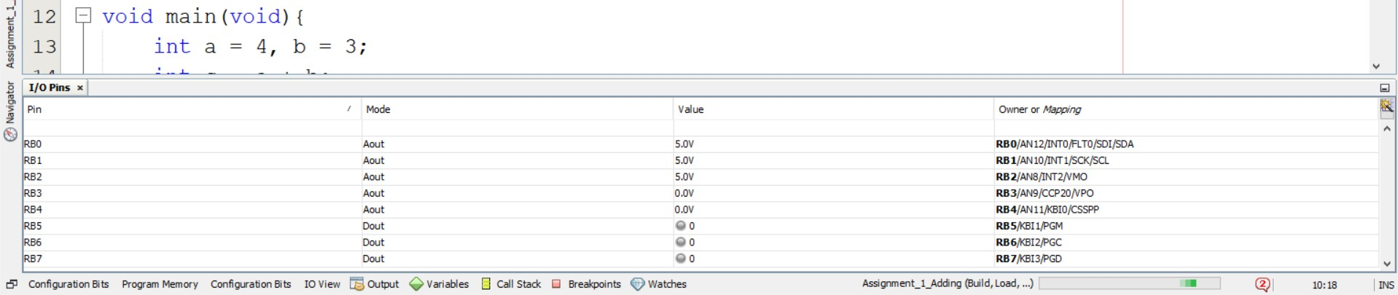

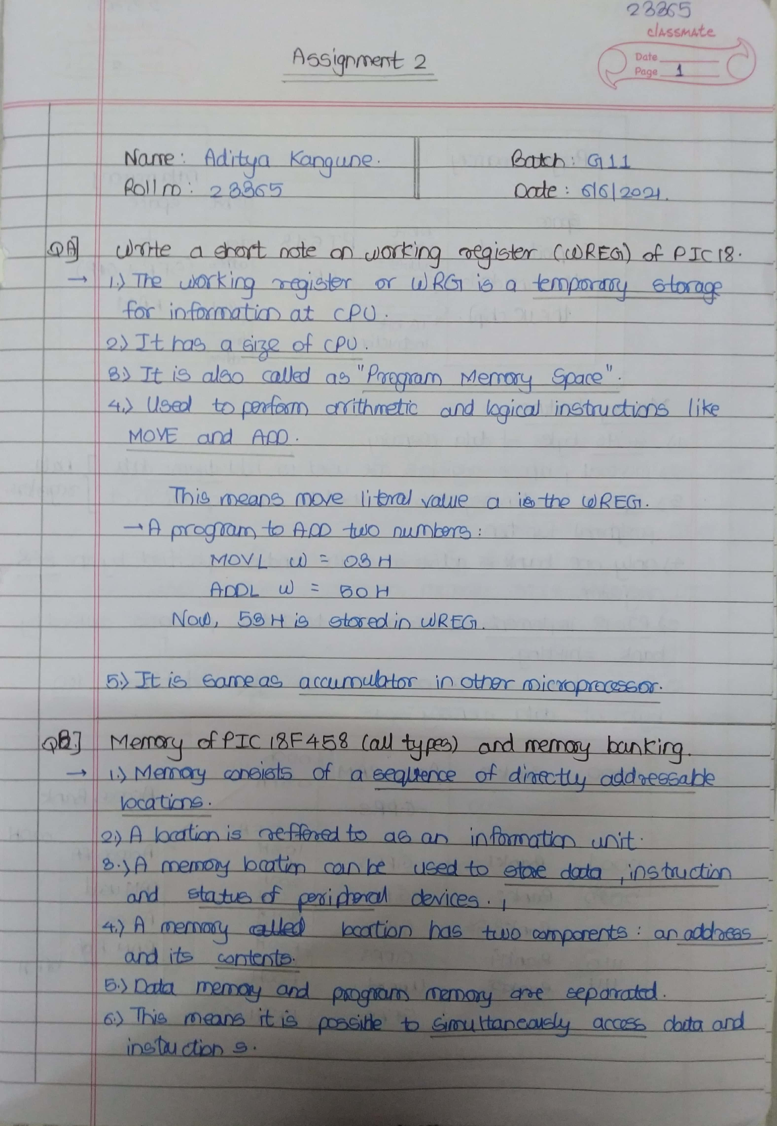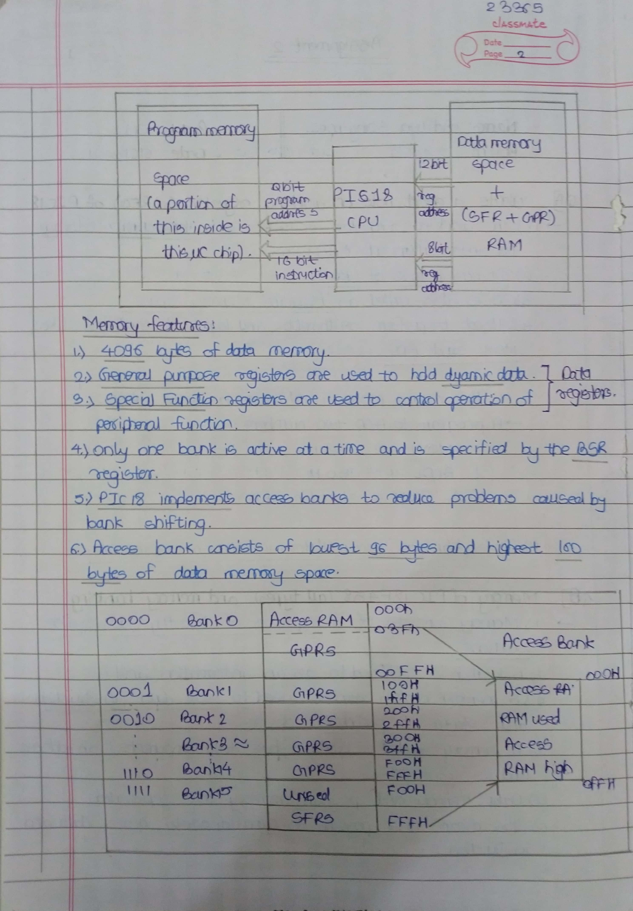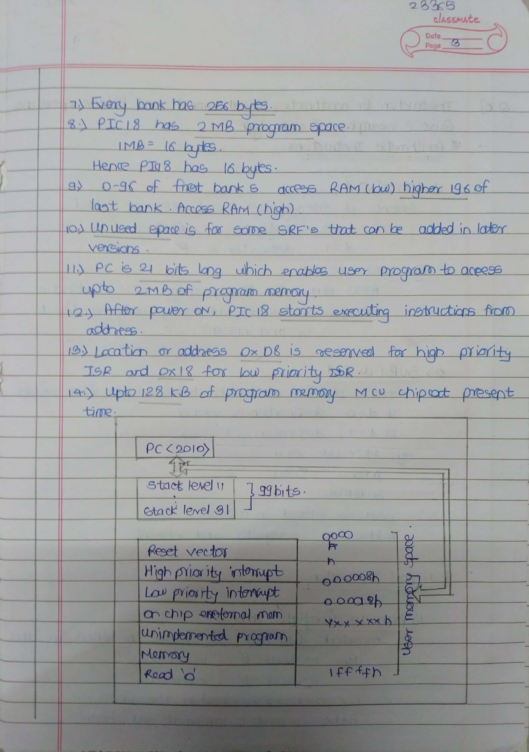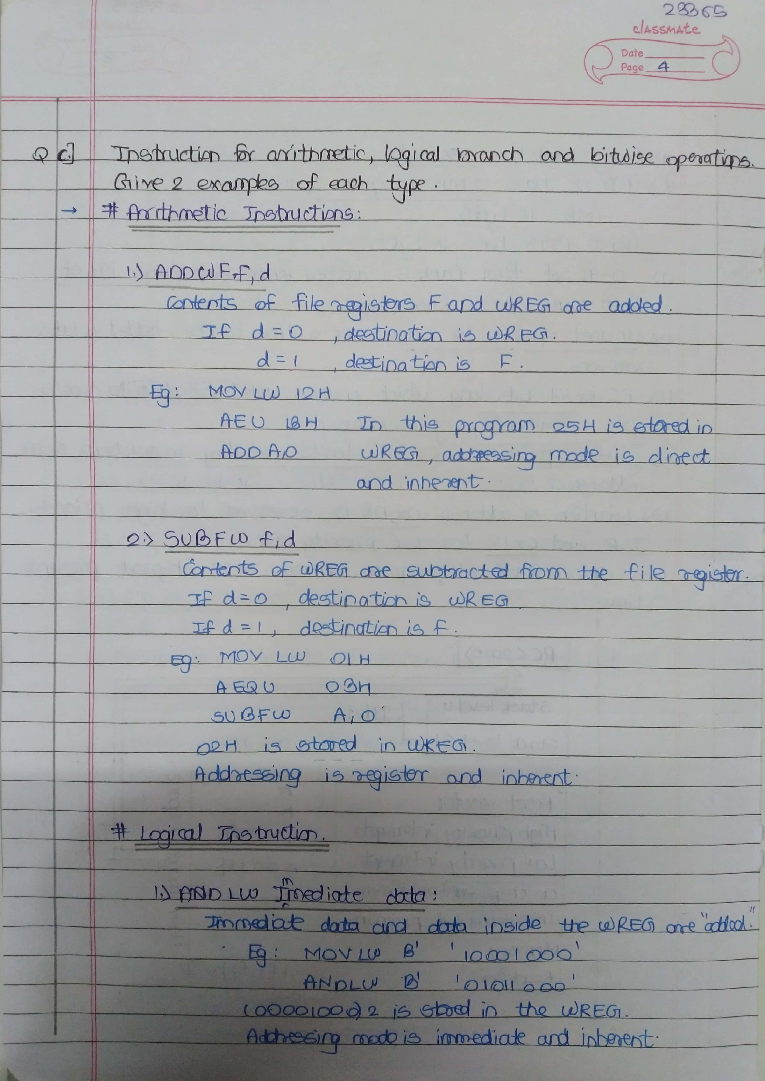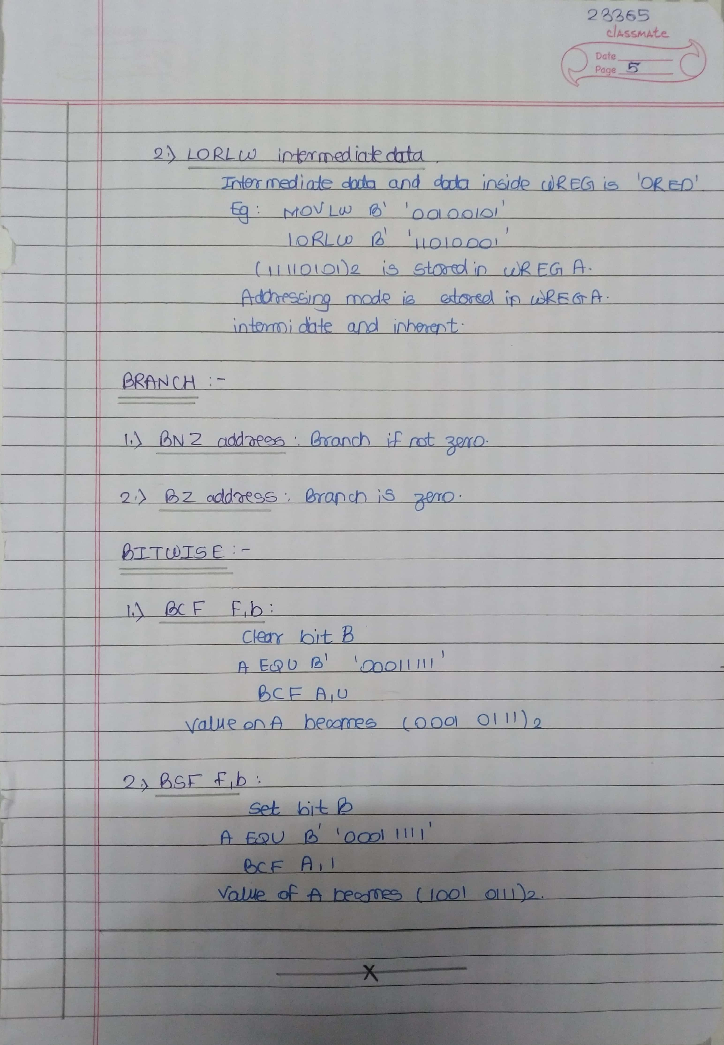

# **Assignment 2 Input-**

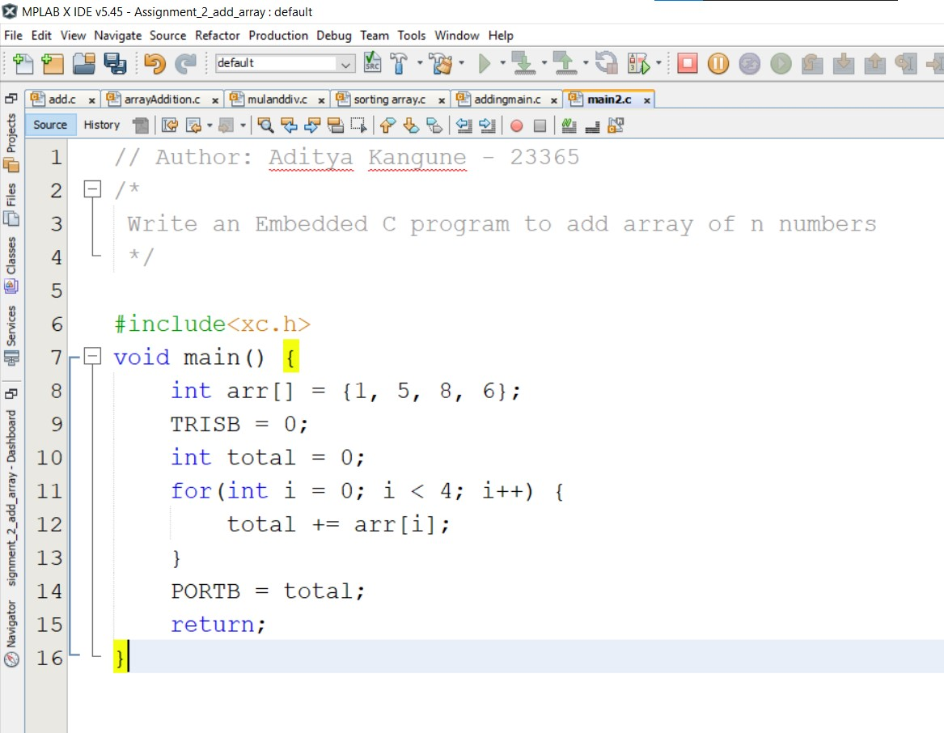

# **Assignment 2 Output-**

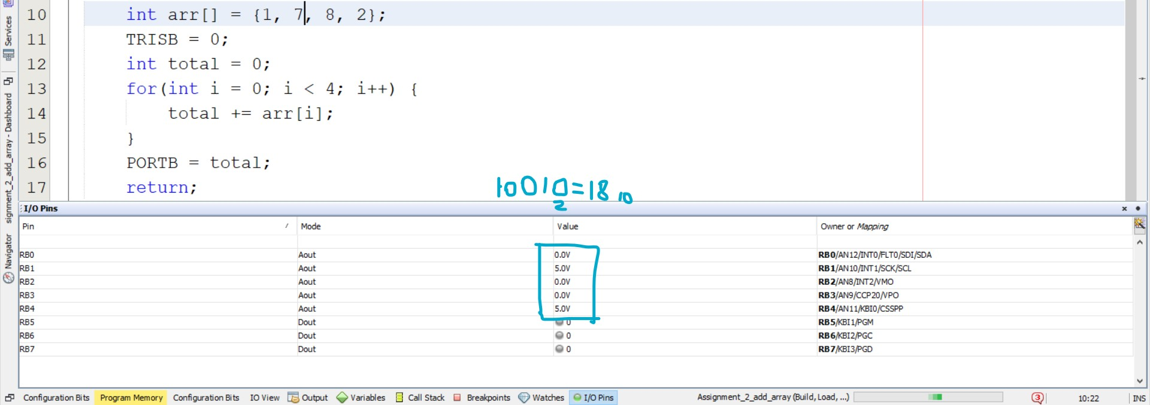

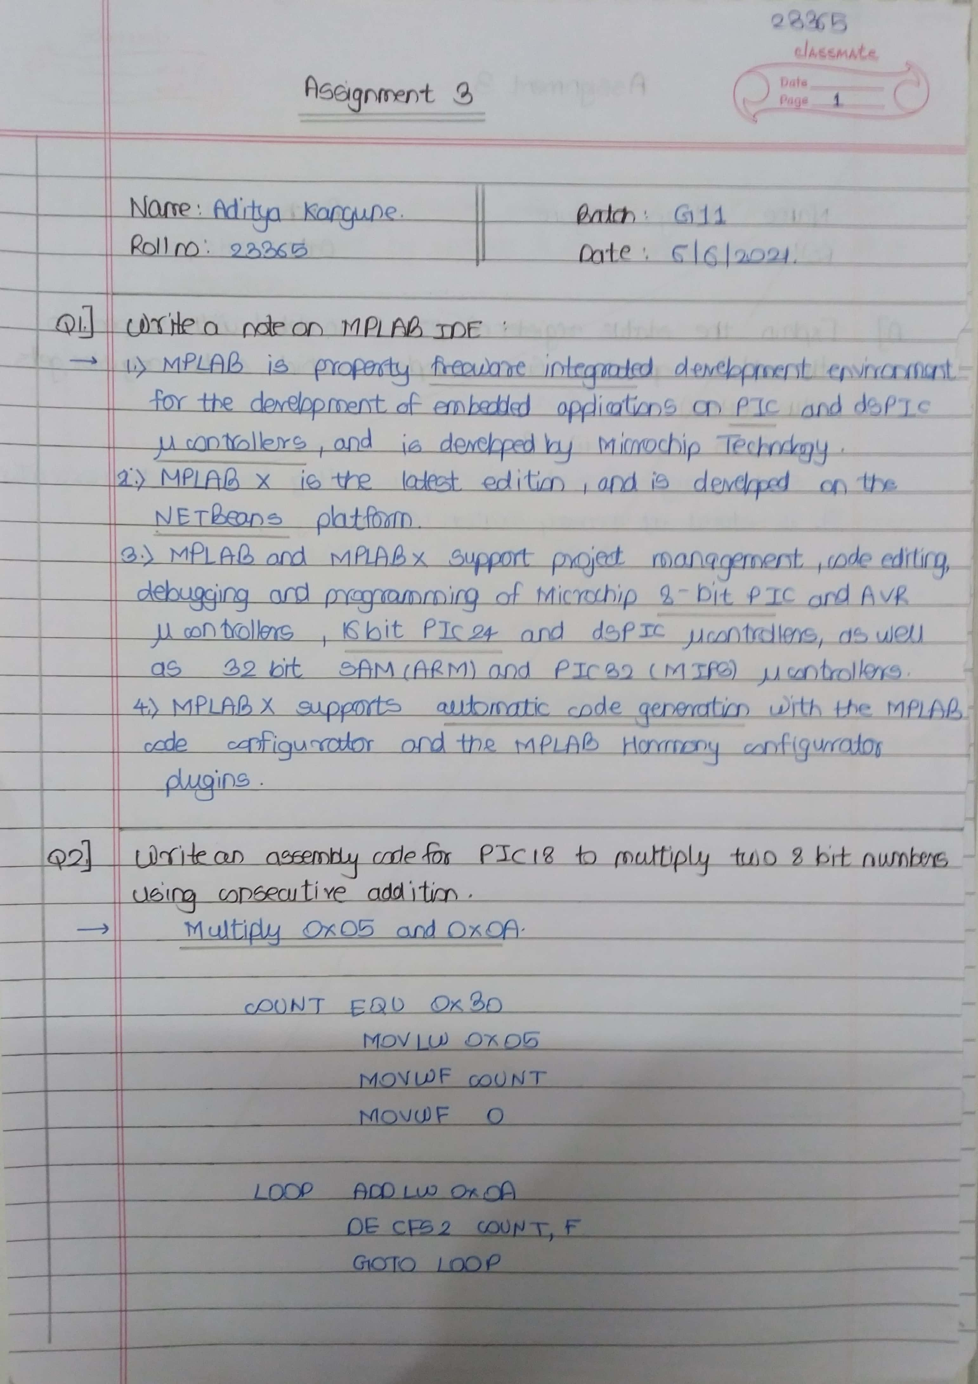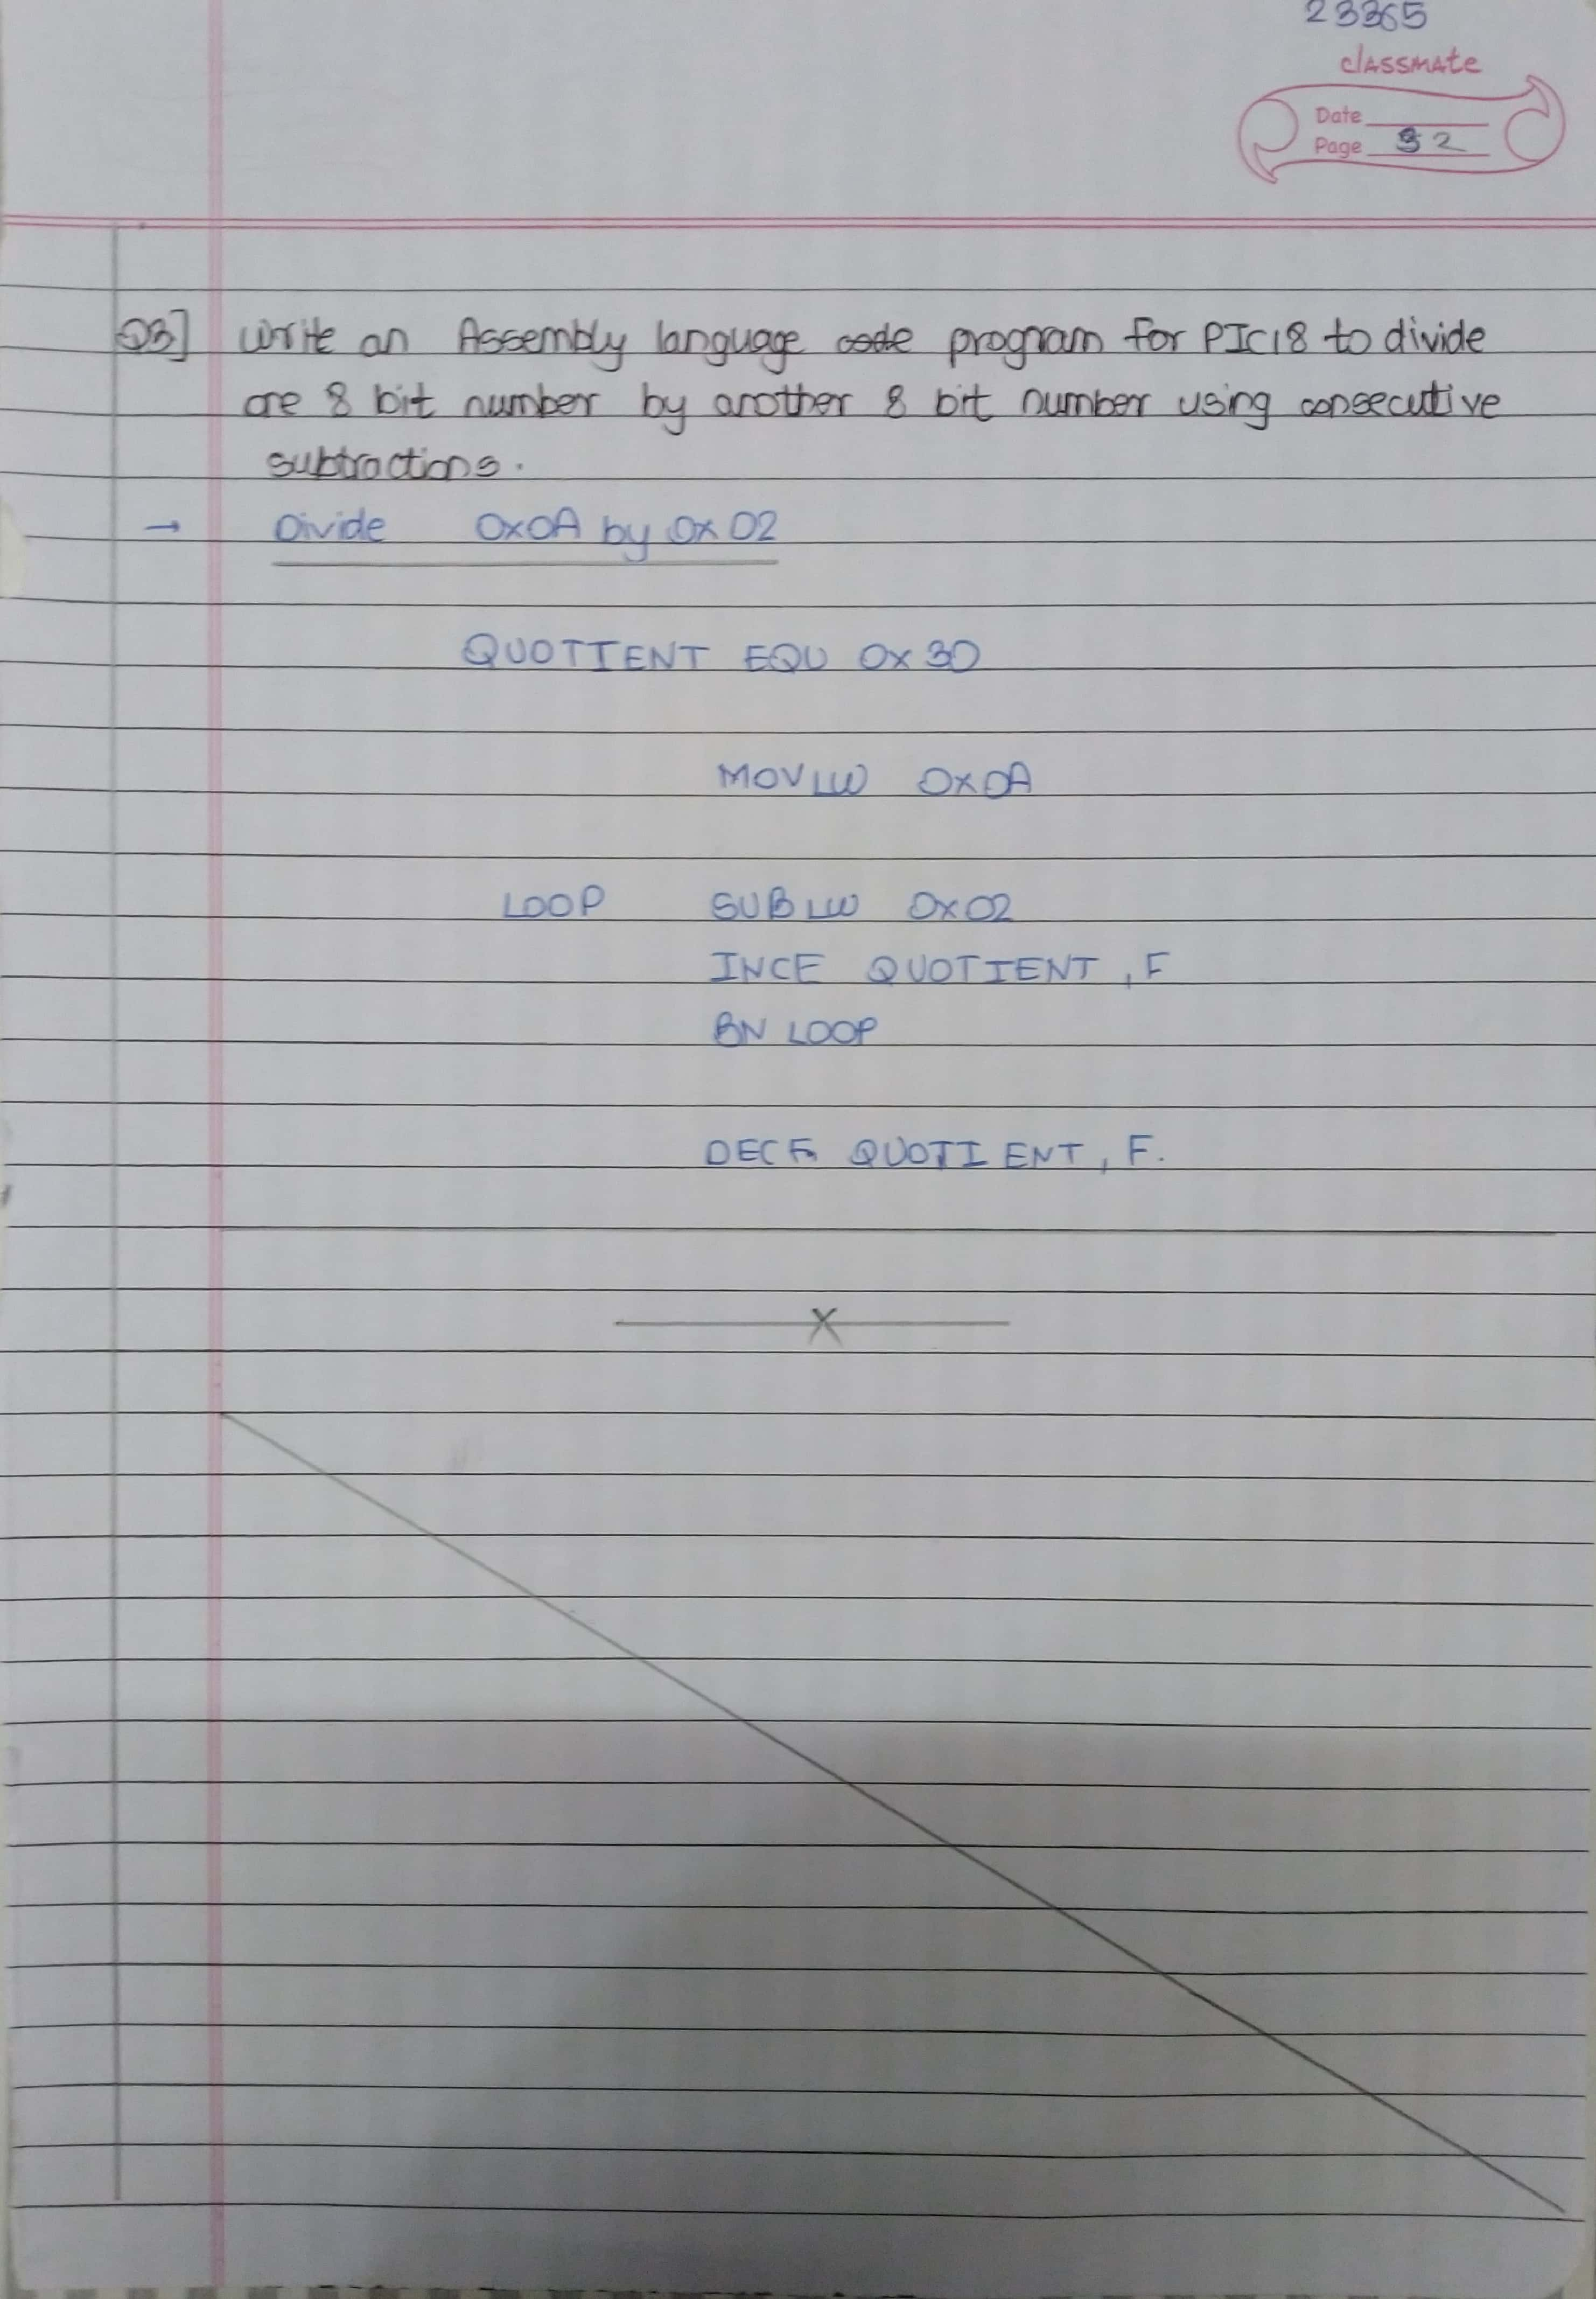

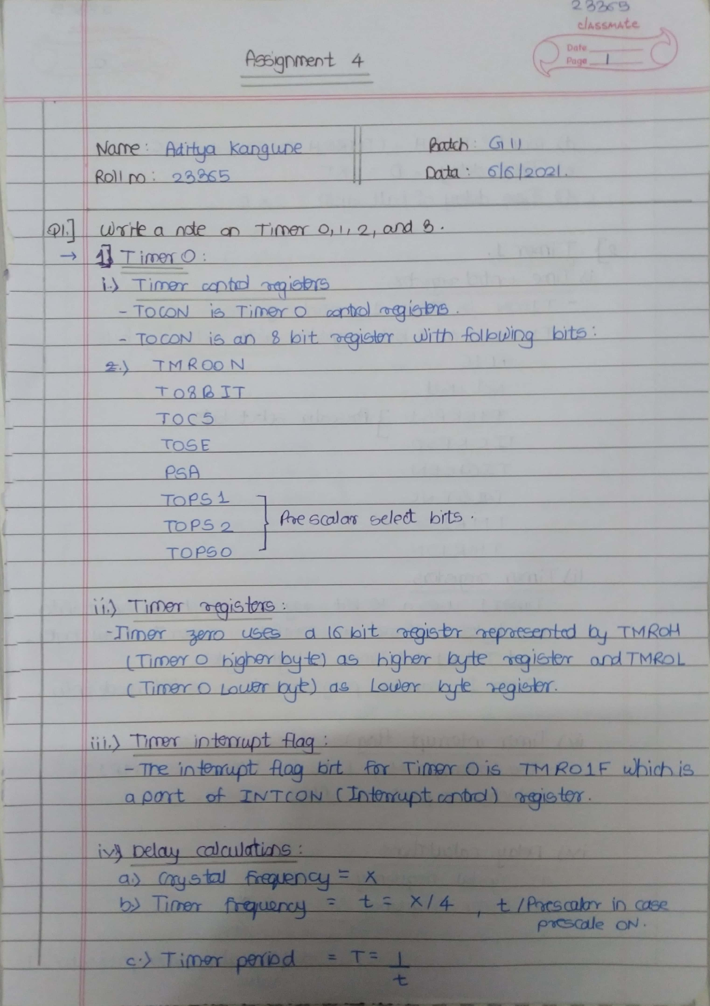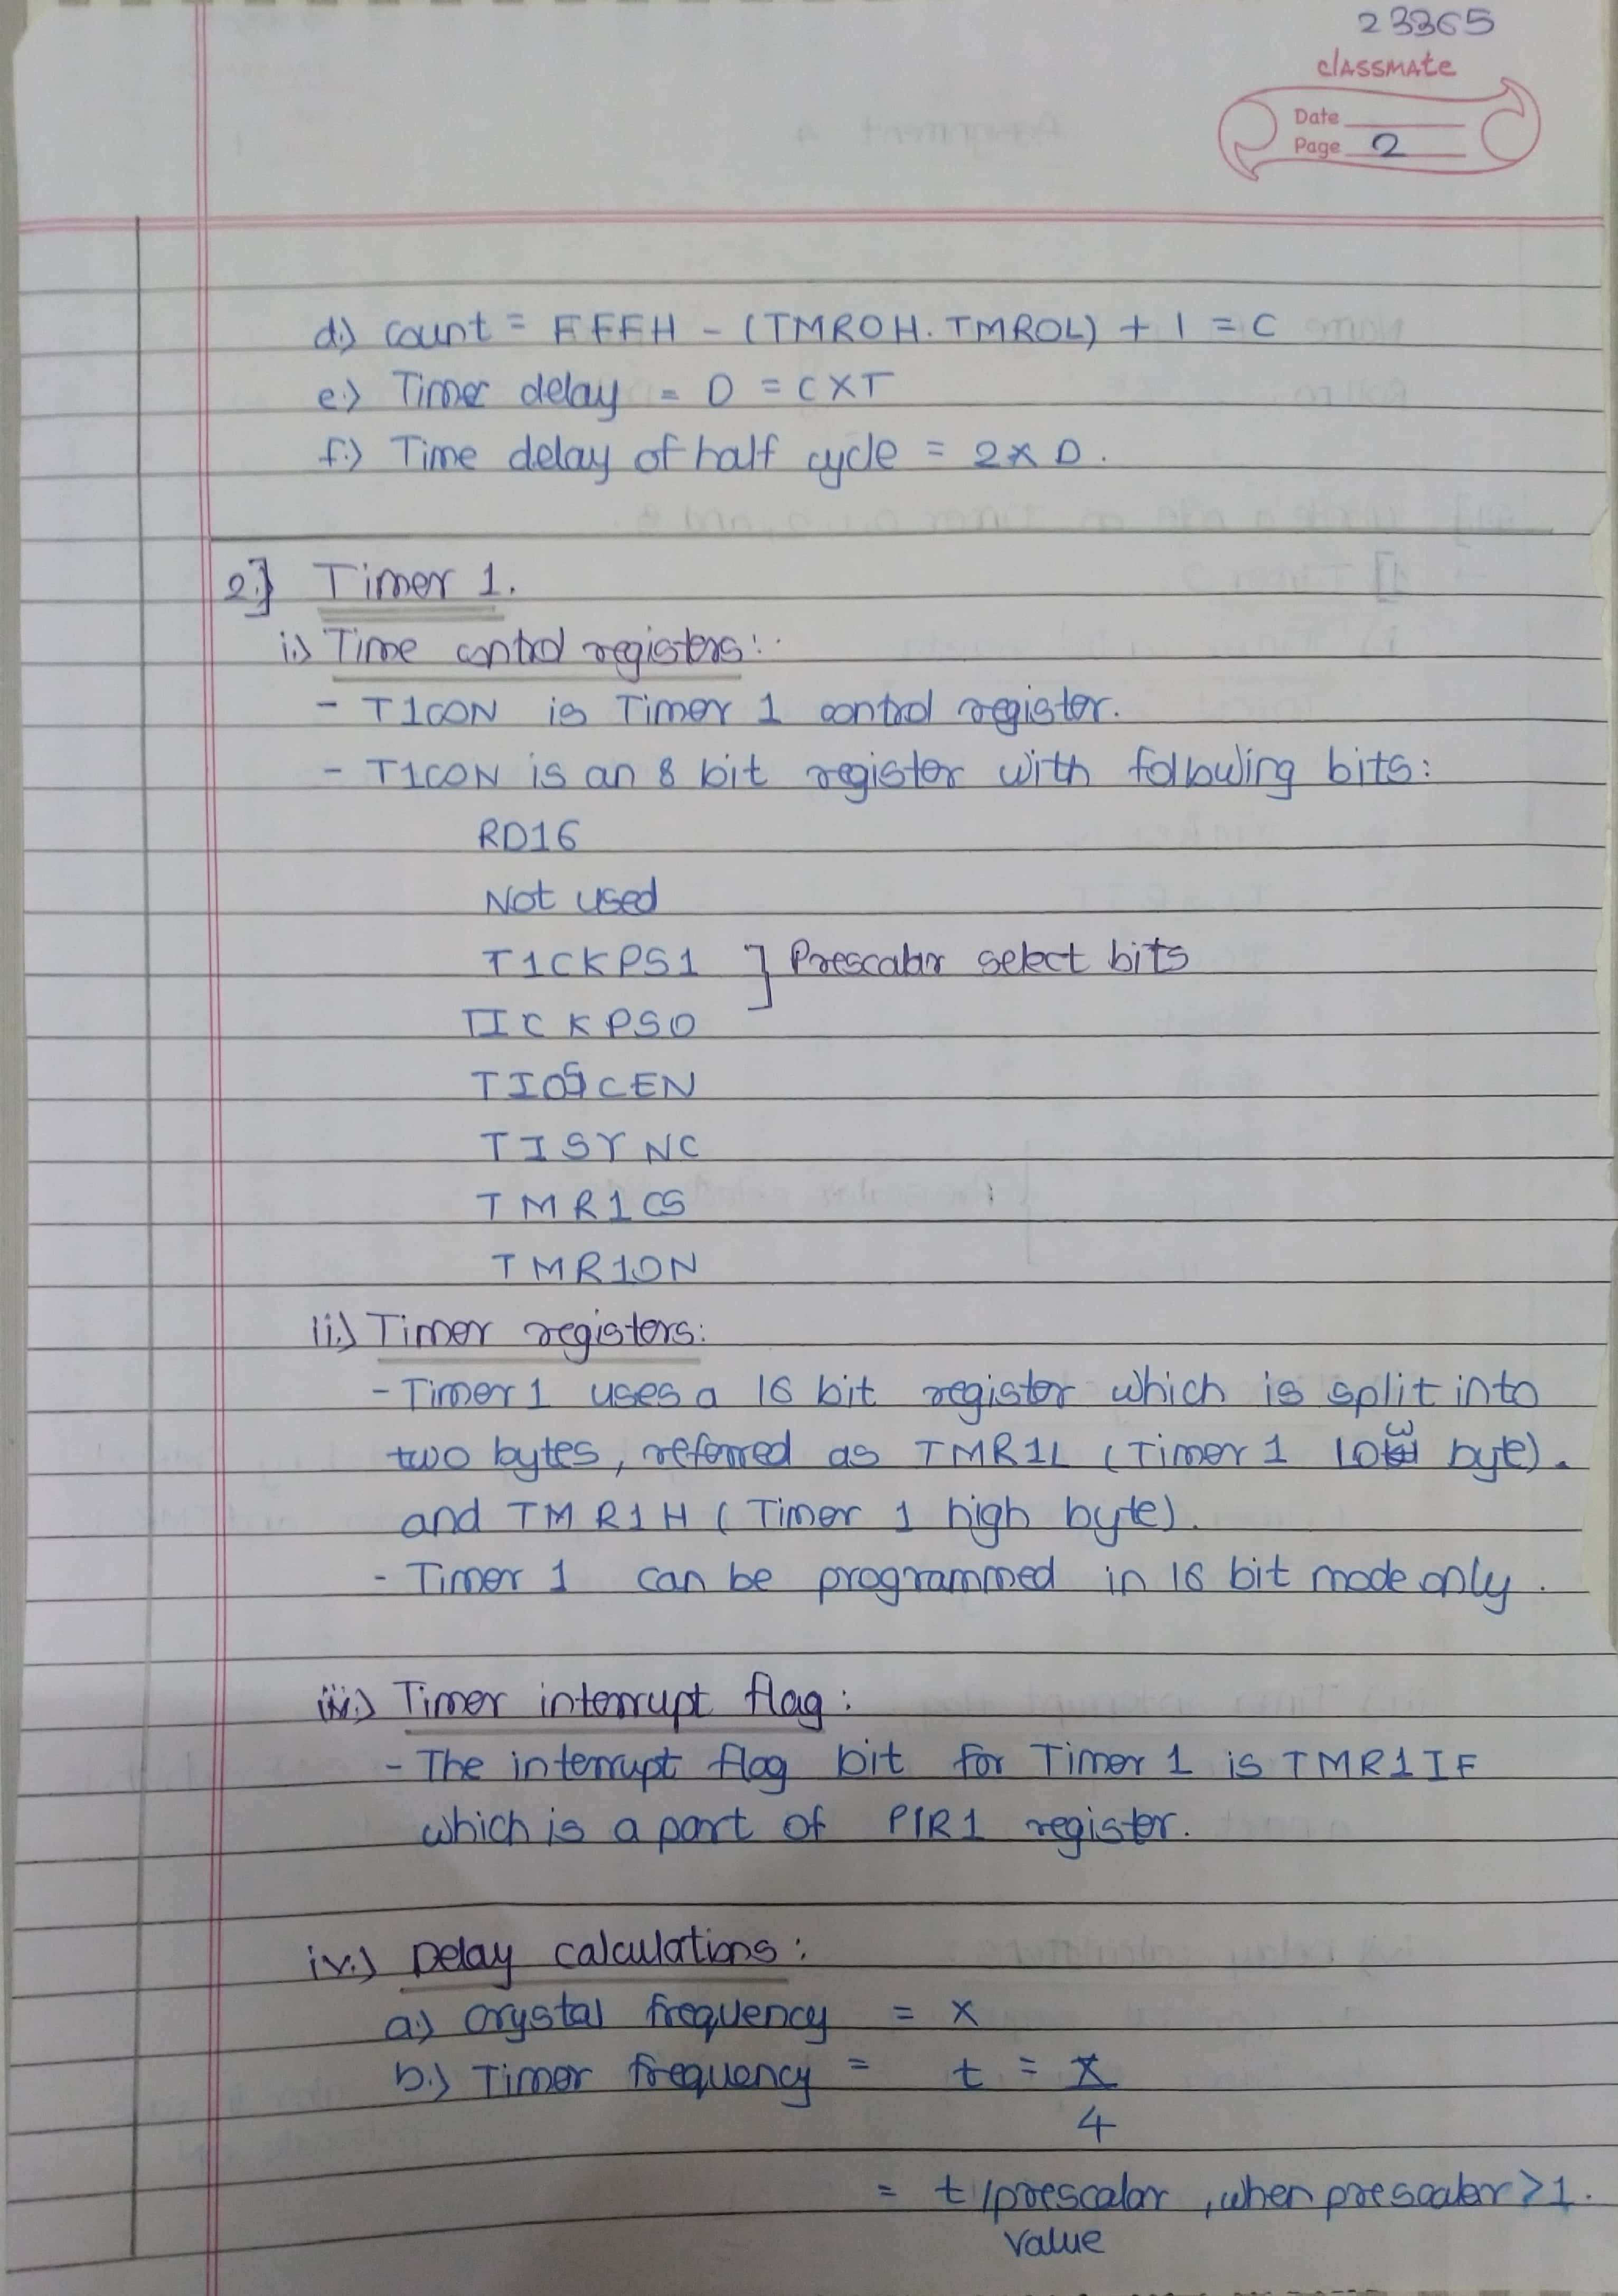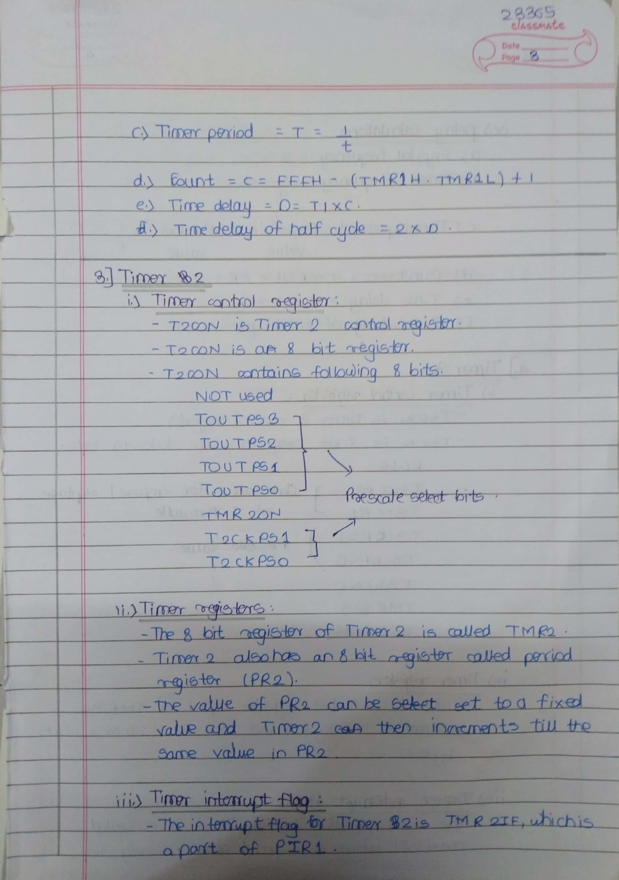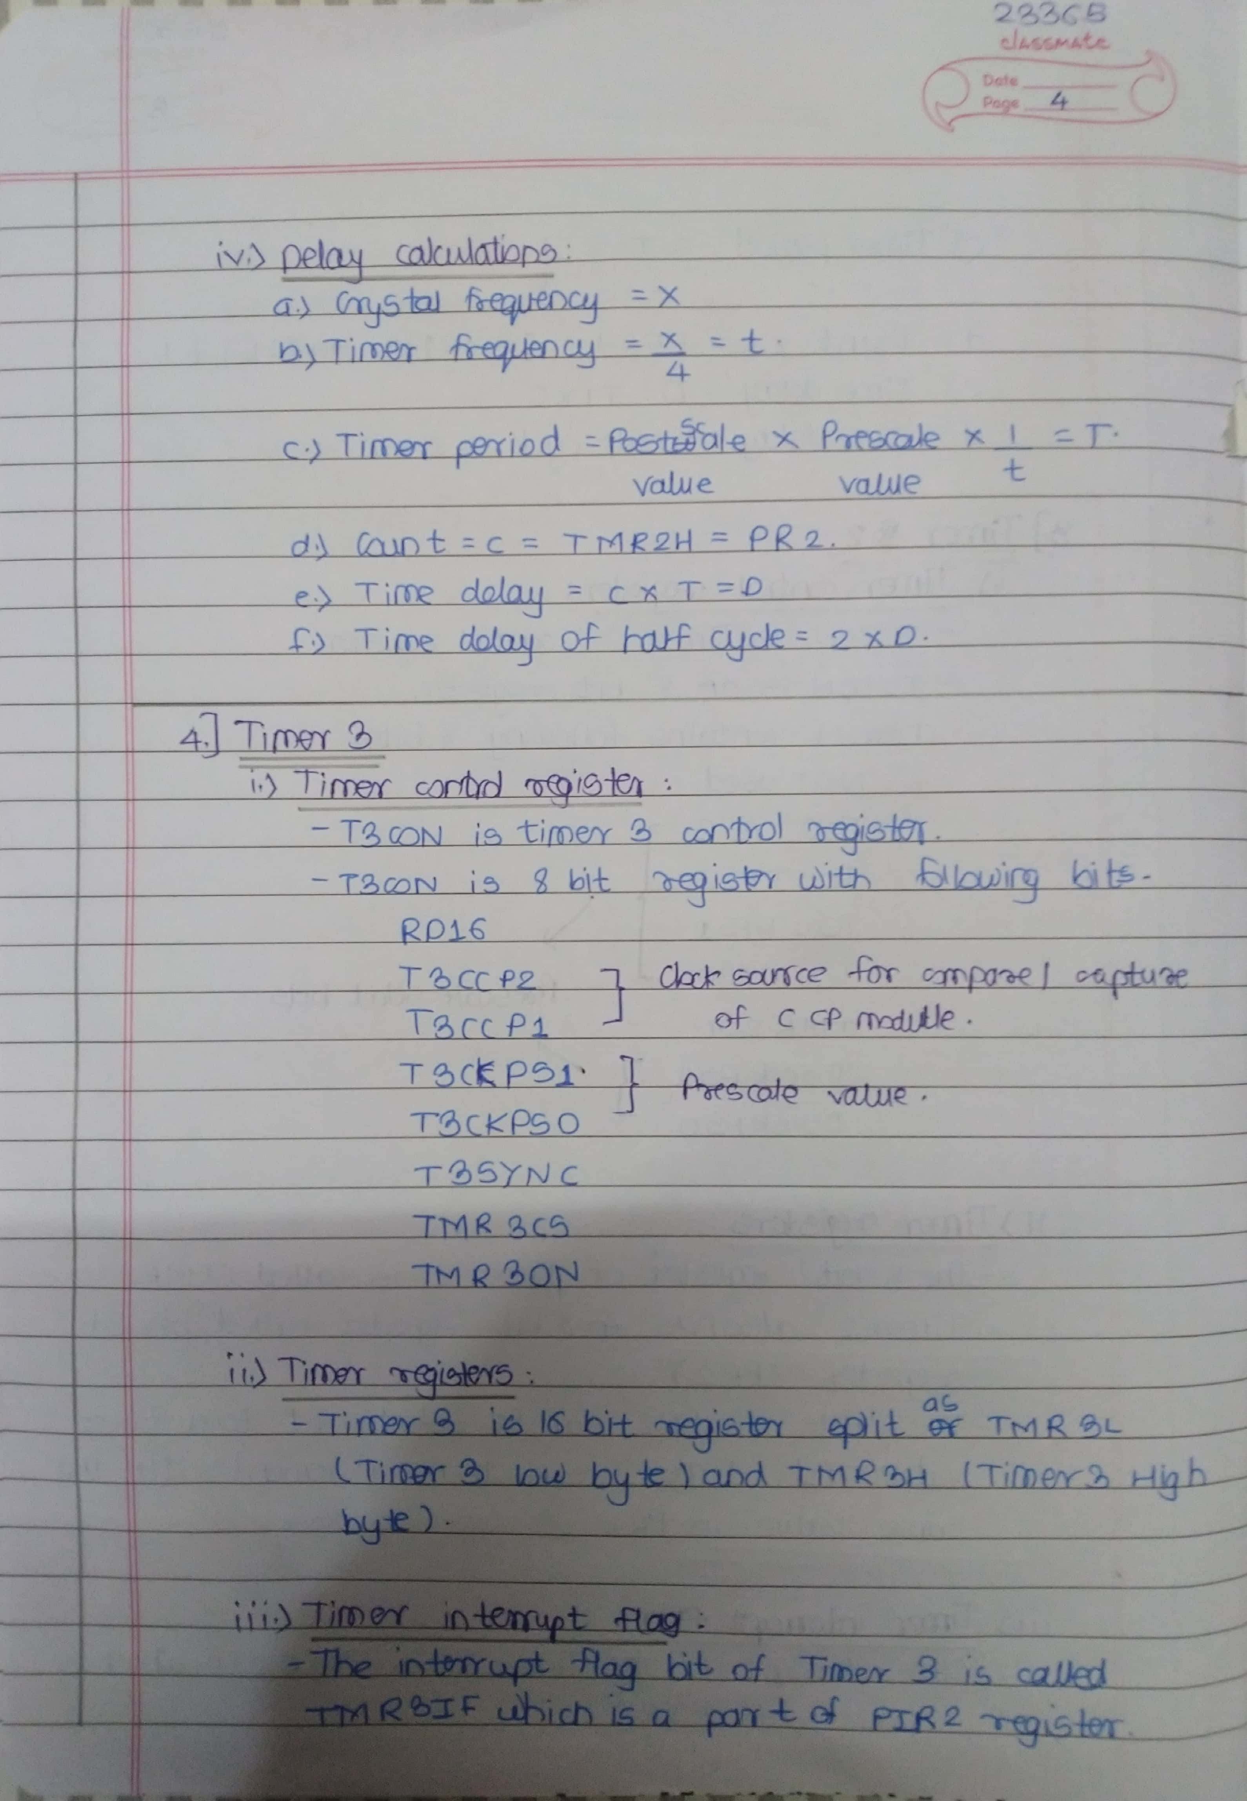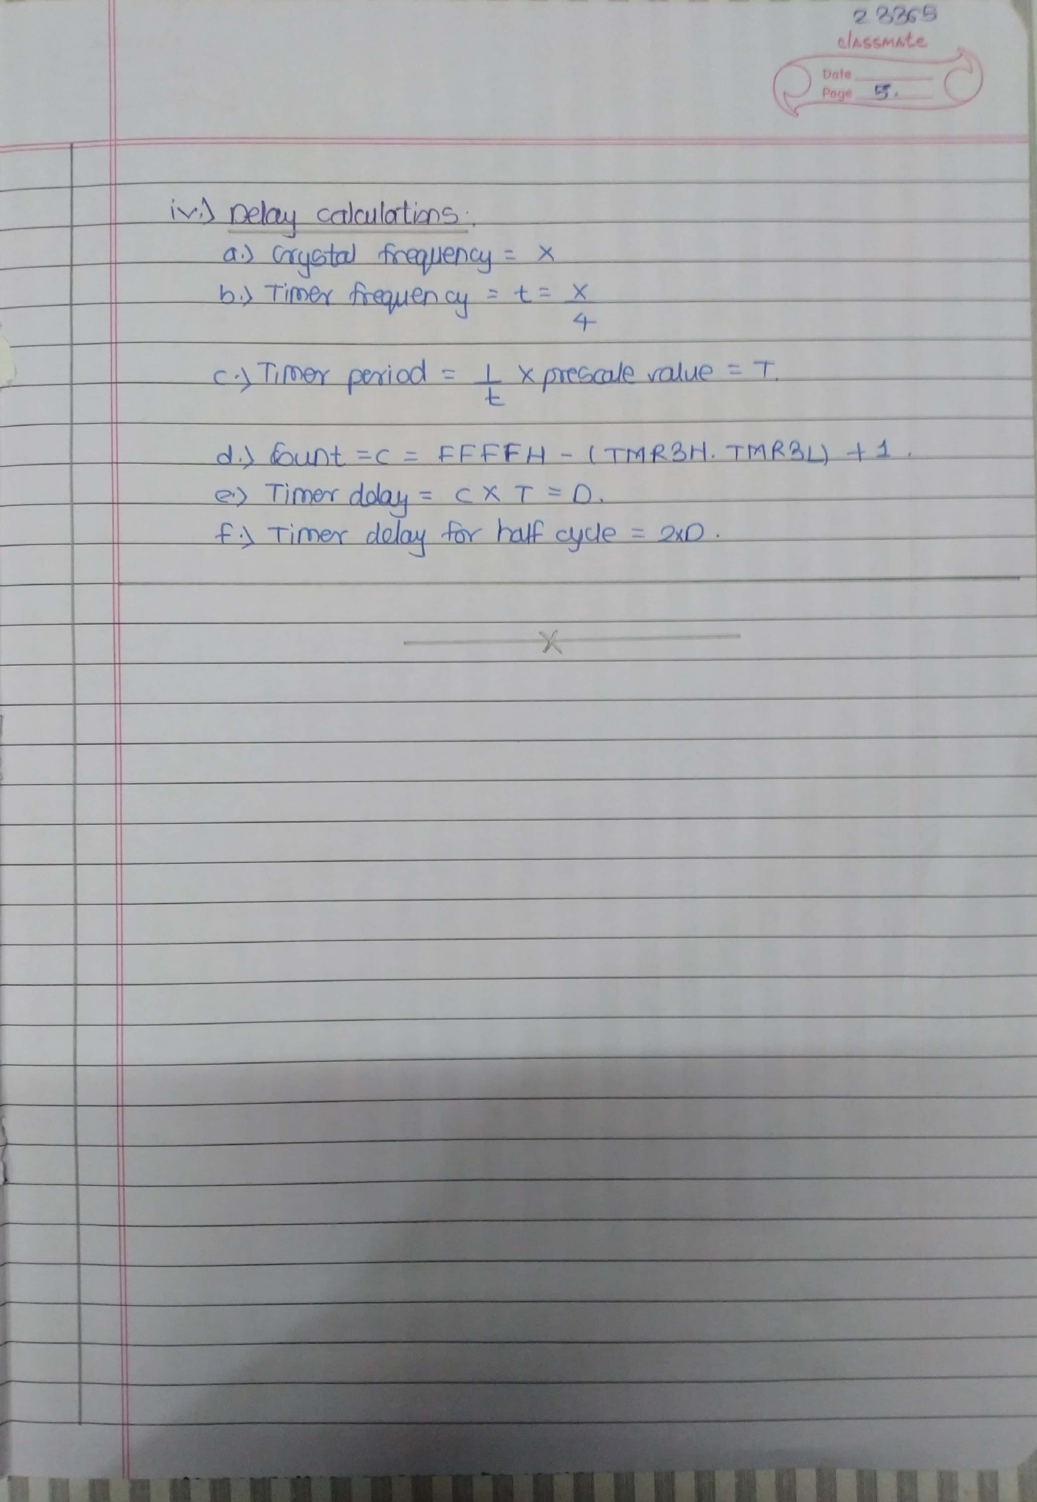

# **Assignment 4 Input-**

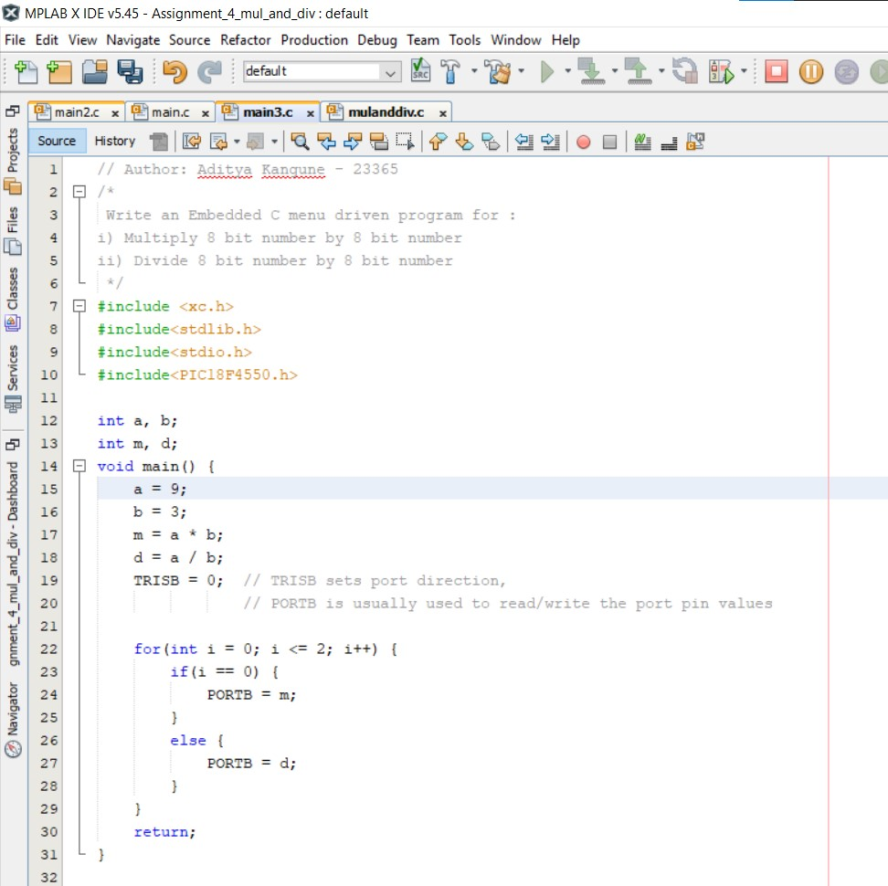

# **Assignment 4 Output-**

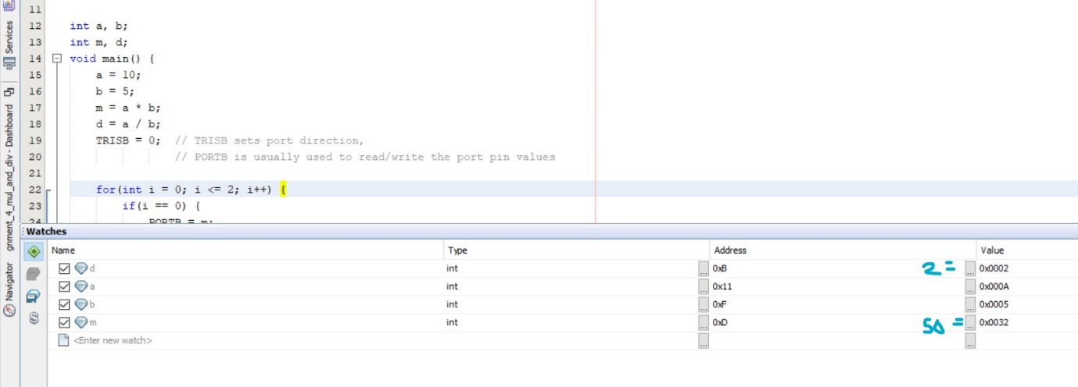

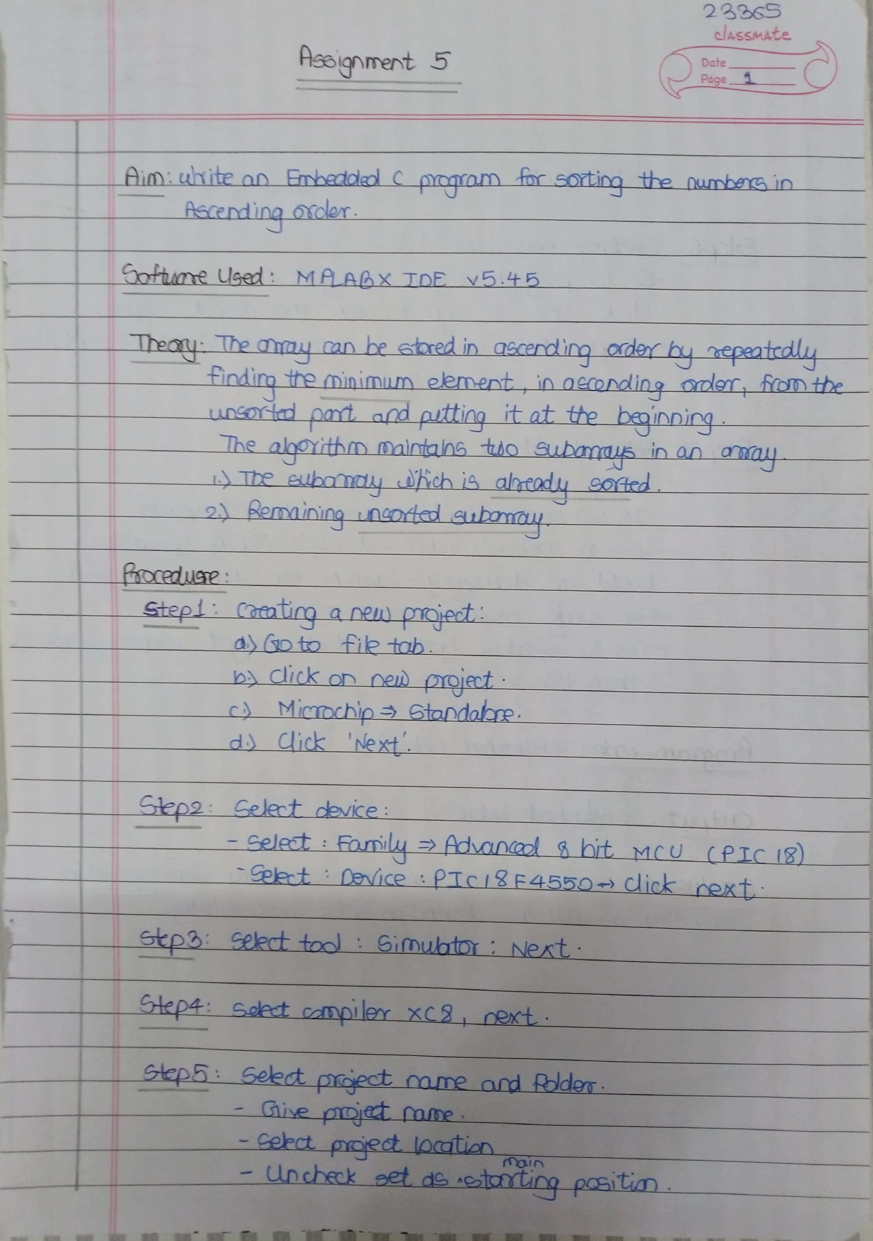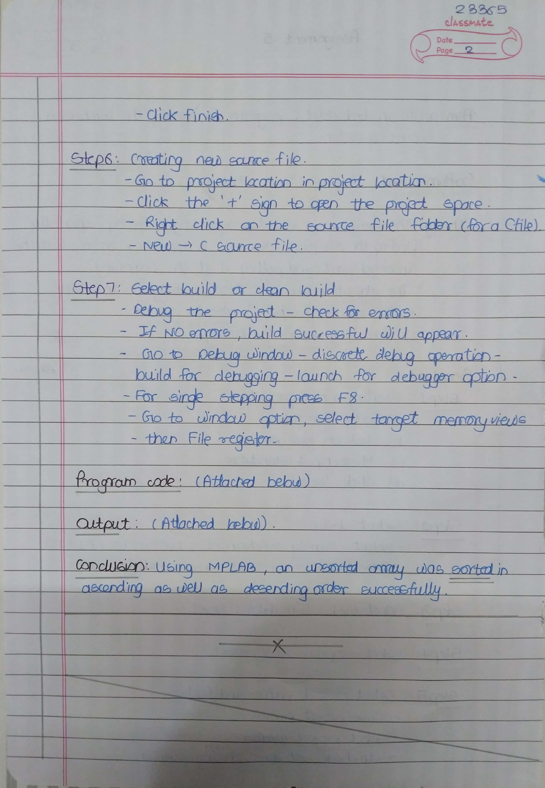

# **Assignment 5 Input-**

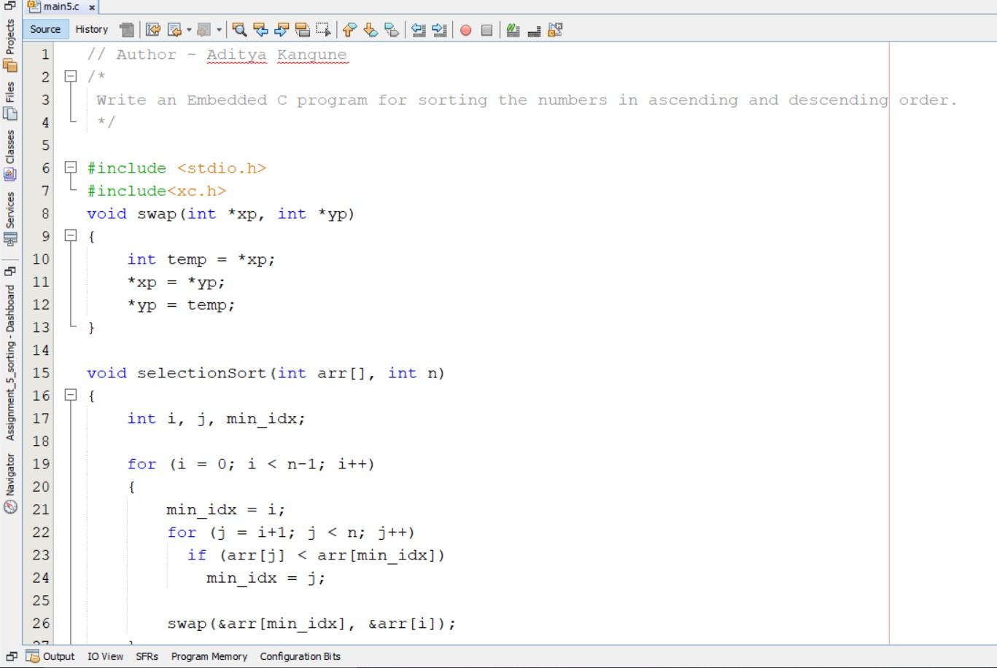

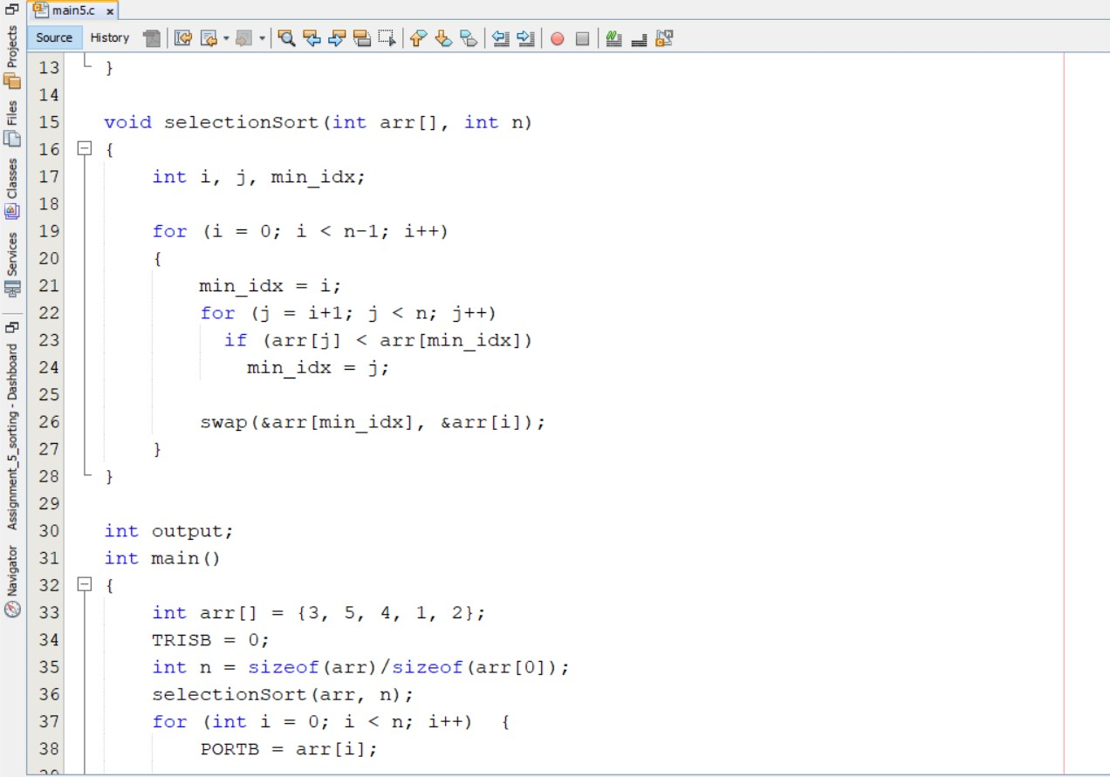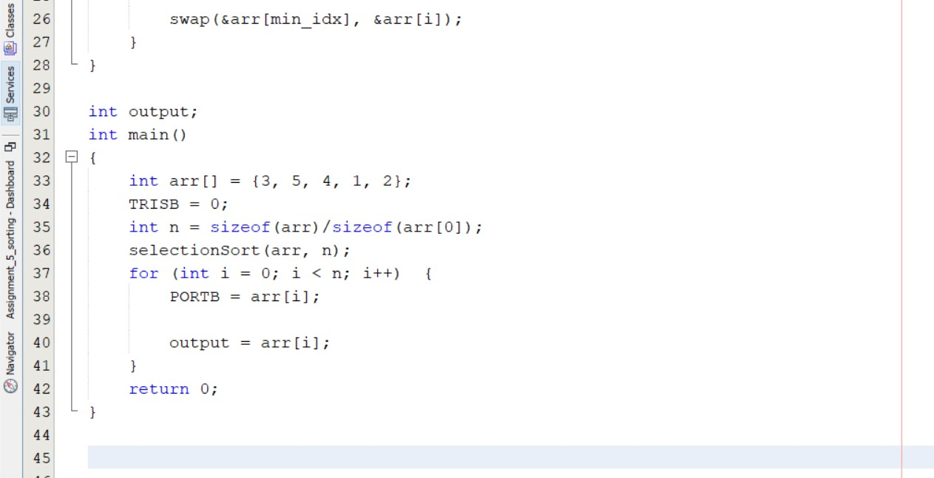

// Author - Aditya Kangune – 23365 – Assignment 5

/*

Write an Embedded C program for sorting the numbers in ascending and descending order.

*/

#include <stdio.h>

#include<xc.h>

void swap(int *xp, int *yp)

{

int temp = *xp;

*xp = *yp;

*yp = temp;

}

void selectionSort(int arr[], int n)

{

int i, j, min_idx;

for (i = 0; i < n-1; i++)

{

min_idx = i;

for (j = i+1; j < n; j++)

if (arr[j] < arr[min_idx])

min_idx = j;

swap(&arr[min_idx], &arr[i]);

}

}

int output;

int main()

{

int arr[] = {3, 5, 4, 1, 2};

TRISB = 0;

int n = sizeof(arr)/sizeof(arr[0]);

selectionSort(arr, n);

for (int i = 0; i < n; i++) {

PORTB = arr[i];

output = arr[i];

}

return 0;

}

# **Assignment 5 Output -**

arr = {3, 5, 4, 1, 2} // Unsorted

1-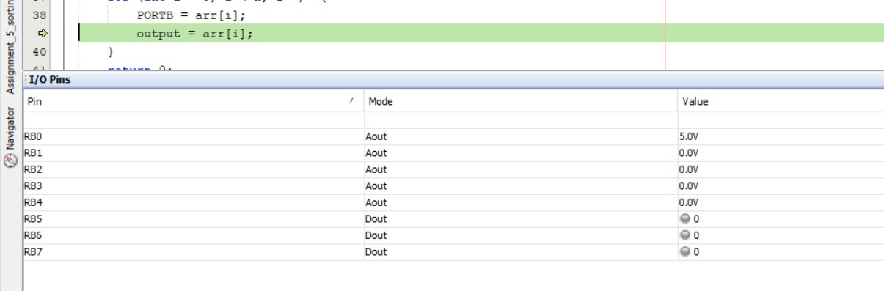

2-

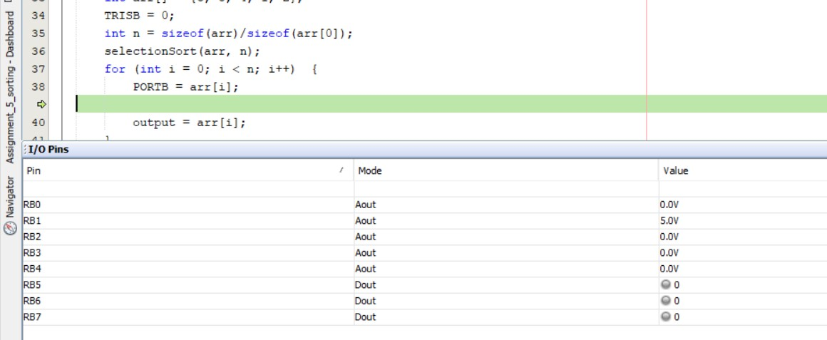

3-

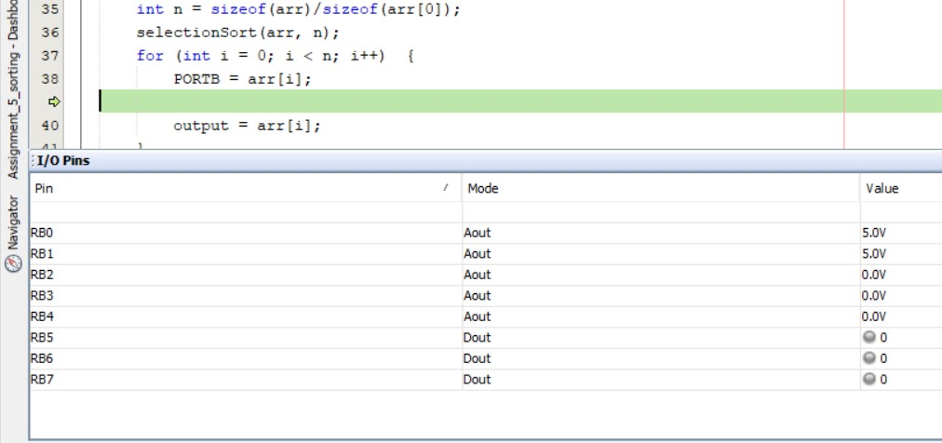

4-

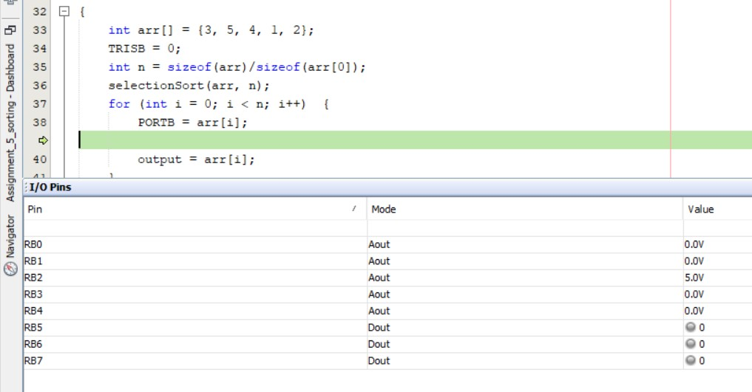

5-

